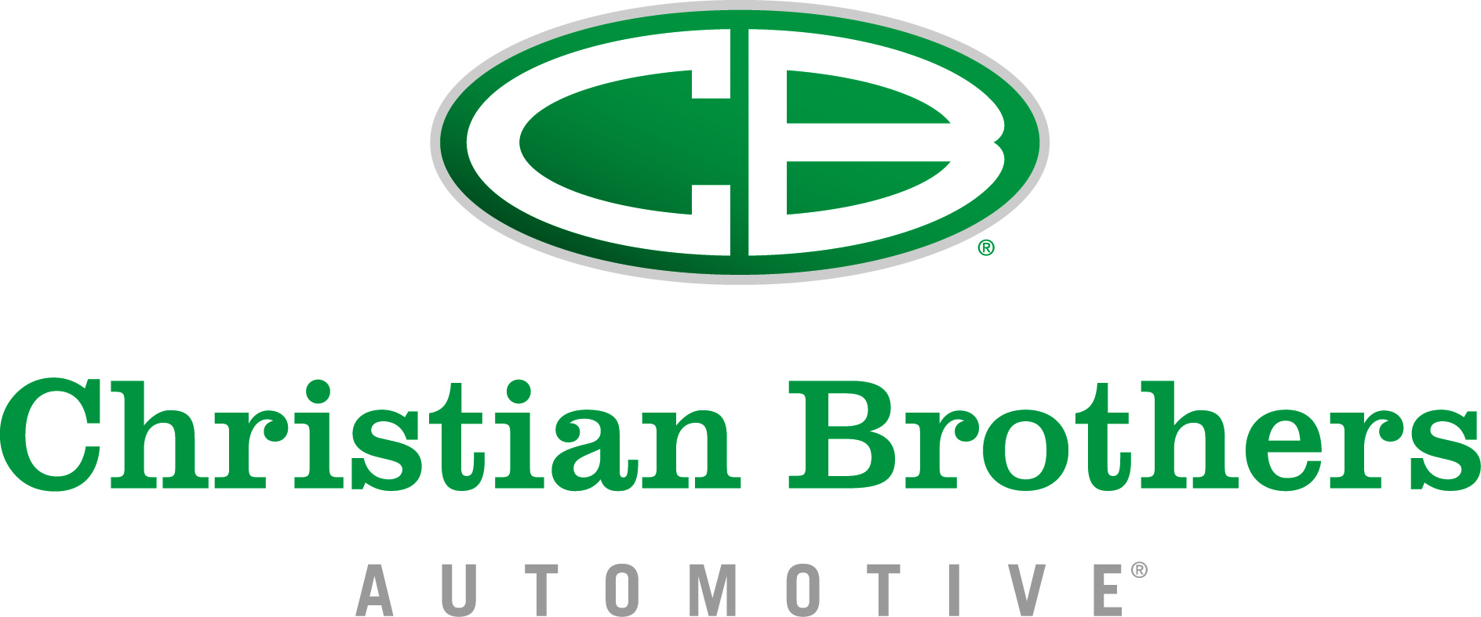
FRANCHISEE PROFILE:
Christian Brothers Automotive
Name: Charles Yun
Opening Date: May 26, 2015 (soft opening)
Address: 8705 Holly Springs Road, Apex
Local Community: Western Wake, NC (Western part of Wake County)
Chapel Hill
Phone Number: 516-996-8780
Email: Charles.yun@cbauto.net
Charles Yun moved to America from South Korea with his family when he was 9-years-old. In order to provide for his family, his father opened his own dry-cleaning business in Brooklyn in 1978. His father did not have a grasp of the English language, but he always had a passion for helping people and running his business ethically.
After graduating from Auburn University with a degree in Economics, Charles decided to pursue his desire to work on Wall Street as an Equity Trader, but technological advancements overtook his position and he was forced to look for a job elsewhere.
With two kids and a wife to consider, Charles looked for a place they could settle down that offered his children the best possible education they could receive and a new business opportunity for himself. Chapel Hill was the perfect option. Charles started comparing different franchise opportunities in the area but couldn’t find an opportunity that stood out.
During one of his drive-around property searches, Charles’ check engine light came on, signifying that his catalytic converter had broken for the second time. He thought of this as a sign that this is the type of industry he needed to consider.
After remembering a banner ad for Christian Brothers, Charles researched the company and realized it was the perfect fit.
Charles had never been very religious prior to finding Christian Brothers, although his wife has always been a Baptist. Two weeks prior to beginning his career with the company, Charles was baptized.
Charles’ wife, Kimberly, is a Sunday school teacher at Korean-American Baptist Church Hanmaum. His two children are ages 15 and 13.
“Everything will be done ethically and properly,” said Charles. “Just the way my father did it.”

ABOUT CHRISTIAN BROTHERS AUTOMOTIVE
Christian Brothers Automotive is one of the nation’s leading automotive service and repair franchise systems, with more than 135 locations in 18 states, including Alabama, Arizona, Arkansas, Colorado, Florida, Georgia, Indiana, Kansas, Louisiana, Michigan, Mississippi, Missouri, Nebraska, North Carolina, Oklahoma, Tennessee, and Texas.
Mark Carr, president and CEO, opened the first location in Houston, Texas in 1982. The store’s main principle was to run an automotive repair facility based on honesty, integrity, reliability and exceptional customer service, which is still the core philosophy of Christian Brothers Automotive today. Christian Brothers Automotive began selling franchises in 1996 and continues to grow at a pace of 15 to 20 stores annually. The company also continues to maintain a 100 percent success rate with its store operations, never having closed a location."

